What is Hystrix ?

Hystrix is a fault tolerance library .

Hystrix internally follows the Circuit Breaker Design Pattern .

Circuit Breaker detects the failure & prevents the application to trying to perform the operation until its safe to retry .

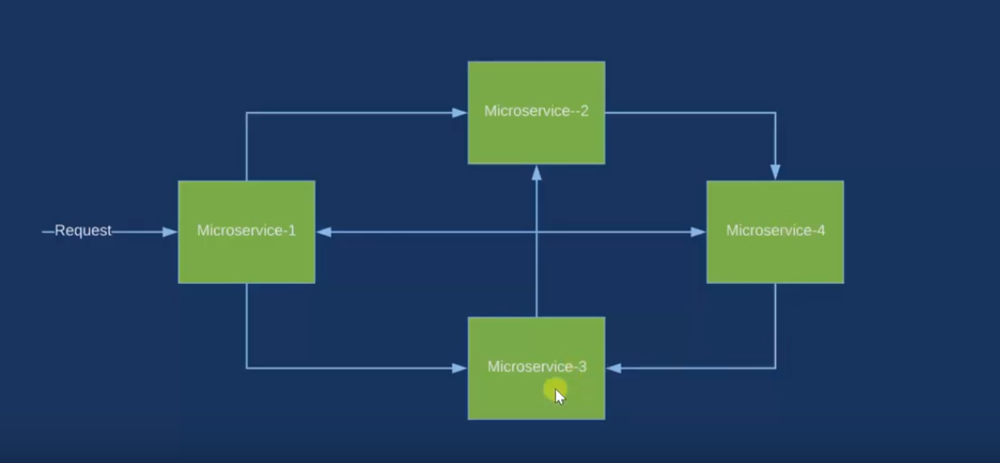

To work with Hystrix Dashboard we need to add Actuator Dependency

<http://localhost:8084/hystrix>